# Artificial intelligence Course for Everyone

## Week 1

### Introduction

* 13 trillion dollar industry by 2030
* Demystifying AI
  + ANI (Artificial narrow intelligence)
    - Smart speaker, self-driving cars, web search, farming and factories
  + AGI (Artificial general intelligence)
    - No progress in AGI

### What is AI?

* Machine learning
* Data
* What makes an AI company
* What machine learning can and cannot do
* Intuitive explanation of deep learning

### Machine Learning

#### Supervised Learning

* A to B mapping

### What is Data?

#### Use and misuse of data

Don’t through data at an AI team and assume it will be valuable

#### Data is messy

* Garbage in garbage out
* Data problems
  + Incorrect labels, missing values
* Multiple types of data
  + Images, text, audio, video (unstructured data)

### The terminology of AI

|  |  |
| --- | --- |
| **Machine learning** | **Data science** |
| Field of learning that gives computers the ability to learn without explicitly programmed. | Science of extracting knowledge and insight from data |

### Deep Learning

* Artificial neural network
  + Neural network were originally inspired by the brain, but the detail of how they work are almost completely unrelated to how biological brain works.
* Neuron

### AI has many tools

* Machine learning and data science
* Deep learning/ neural network
* Other buzzword: unsupervised learning, reinforcement learning, graphical models, planning, knowledge, graph

### What makes an AI company

#### AI Transformation

1. Execute pilot projects to gain momentum
2. Build an in-house AI team
3. Provide broad AI training
4. Develop an AI strategy
5. Develop internal and external communications

### What Machine learning can or cannot do

#### What makes an ML problem easier?

1. Learning a simple concept
   1. <= in seconds
2. Lots of data available
   1. A > B mapping

#### Strength and weakness of Machine learning

1. ML tends to work well when:
   1. Learning a simple concept
   2. There is lots of data available
2. ML tends to work poorly when:
   1. Learning complex concepts from small amount of data
   2. It is asked to perform on new types of data

## Week 2

### Building AI Projects

### Workflow of machine learning projects

#### Key steps of a machine learning project

1. Collect data
2. Train model
   1. Iterate many times until good enough
3. Deploy model
   1. Get data back
   2. Maintain/ update model

### Workflow of Data science projects

#### Key steps of a data science project

1. Collect data
2. Analyze data
   1. Iterate many times to get good insight
3. Suggest hypothesis/ action
   1. Deploy changes
   2. Re-analyze new data periodically

### Every job function need to learn how to use data

### Brainstorming framework

* Think about automating tasks rather than automating jobs eg. Call center routing, radiologists.
* What are the main drivers of business value
* What are the main pain points in your business

### You can make progress even without big data

* Having more data almost never hurt
* Data make businesses (like web search) defensible
* But with small datasets, you can still make progress

### Due diligence eon project

* Technical diligence
  + Can AI system meet desired performance
  + How much data is needed
  + Engineering timelines
* Business diligence
  + Lower costs – current business
  + Increase revenues – current business
  + Launch new product or business – New business
* Ethical diligence

### Build or Buy

* ML project can be in-house or out sourced
* DS projects are more commonly in-house
* Something will be industry standards – avoid building those

### Working with AI team

#### How AI team think about dataset

* Training sets
  + ok or defect
* Test sets

#### Pitfall: Expecting 100% accuracy

* Limitation of ML
* Insufficient data
* Mislabeled data
* Ambiguous label

### Technical tools for AI Team

* Machine learning framework
  + Tensorflow, PyTorch, Keras, MXNet, CNTK, Caffe, PaddlePaddle, Scikit-Learn, R, Weka
* Research Publications
  + Arxiv
* Open Source Repositories
  + GitHub

#### CPU Vs. GPU

* CPU : Computer Processor (Central processing Unit )
* GPU : Graphic processing Unit
* Cloud vs. on premises
* Edge deployment (processing on the machine itself like processing within the self-driving car)

## Week 3

### Smart Speaker

Steps to process a command:

1. Trigger word detection
2. Speech recognition
3. Intent recognition
   1. Extract duration b. start timer with set duration
4. Execute words (joke)

### Steps for deciding how to drive

1. Image/ Radar/ Lidar (laser sensor reading)
   1. GPS/ Maps
2. Car detection/ pedestrian detection
3. Trajectory (path/ Line) prediction
4. Motion planning (steer/ accelerate/ brake)

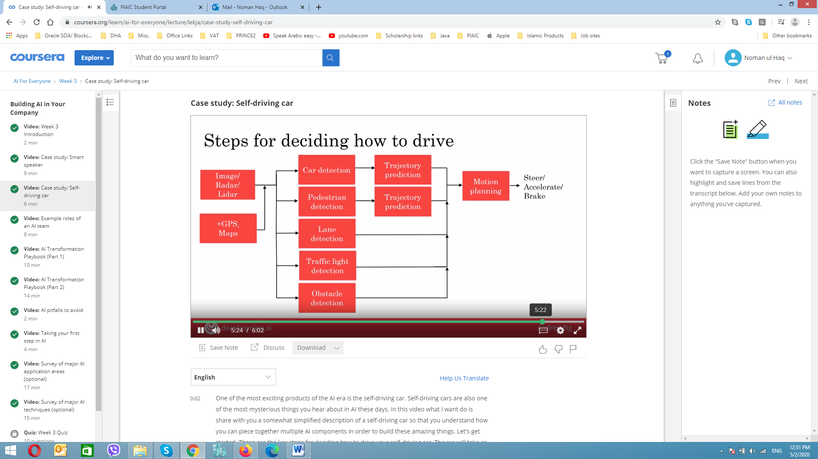

### Example roles

1. Software Engineer
   1. E.g. joke execution, ensure self-driving car reliability
2. Machine Learning Engineer
   1. A > B mapping
3. Machine Learning Researcher
   1. Extend state of art in ML
4. Applied Machine Learning Scientist
   1. In bw MLE and MLR
5. Data scientist
   1. Examine data and provide insight, make presentation to a team/ executive
6. Data Engineer
   1. Organize Data, make sure data is safe in easily accessible, secure and cost effective way
7. AI Product manager
   1. Help decide what to build; what feasible and valuable

### AI Transformation Playbook

1. **Execute pilot project to gain momentum** 
   1. Most important for the initial project to succeed rather than be the most valuable
   2. Show traction within 6-12 months
   3. Can be in house or out-sourced
2. **Built an in-house AI team** 
   1. AI function can be under CTO, CIO, CDO, etc or a new CAIO
3. **Provide Broad AI Training**

|  |  |
| --- | --- |
| **Role** | **What they should learn** |
| Executive and business leaders | * What AI can do for your enterprise * AI strategy * Resource allocation |
| Leaders of divisions working on AI projects | * Set project direction (technical and business diligence) * Resource allocation * Monitor progress |
| AI engineer trainees | * Build and ship AI software * Gather data * Execute on specific AI projects |

1. Develop an AI strategy
   1. Leverage AI to create an advantage specific to your industry sector
   2. Design strategy align with the “Virtues cycle of AI”
      1. Better product > more users > more data

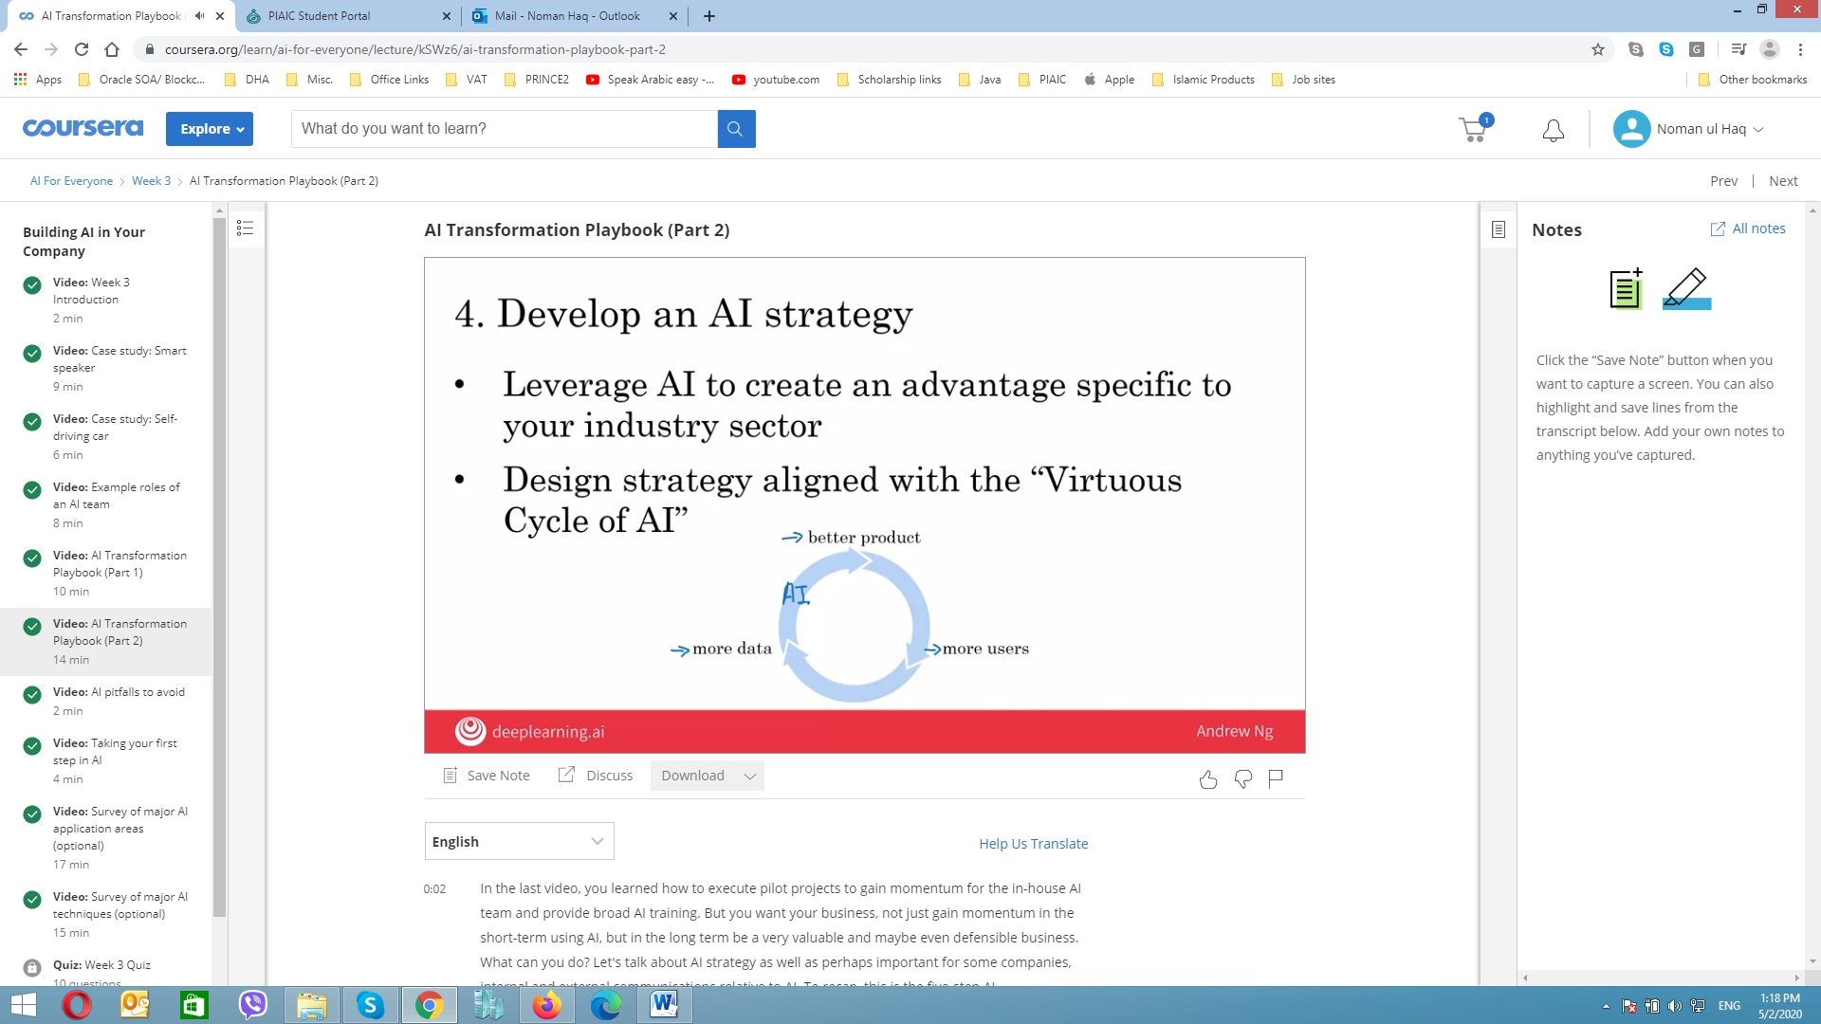

* 1. Consider creating a data strategy
     1. Strategic data acquisition
     2. Unified data warehouse
  2. Create network effects and platform advantages
     1. In industries with “winner take all” dynamics. AI can be an accelerator

1. Develop internal and external communication
   1. Investors relations , Government relations, consumer/ user education, talent/ recruitment, internal communications

### AI Pitfalls to avoid

|  |  |
| --- | --- |
| **Don’t** | **Do’s** |
| Expect AI can do everything | Be realistic about AI can and cannot do given limitation of technology, data and engineering resources |
| Hire 2-3 ML engineers and count solely on them to come up with use cases | Pair engineering talent with business talent and work across functionality to find feasible and valuable project |
| Expect the AI project to work the first time | Plan for AI development to be an iterative process with multiple attempts needed to success |
| Expect traditional planning process to apply without changes | Work with AI team to establish time line, estimates, milestones KPIs etc. |
| Think you need superstar AI engineers before you can do anything |  |

### Some initial steps you can take

**Get Friends to learn AI:** This course and reading books   
**Start brainstorming projects:** No project is too small (and its better to start and get succeed)  
**Hire a few ML/DS people to help**   
**Hire or appoint an AI Leader (VP AI, CAIO, etc.)**   
**Discuss with CEO/ Board possibilities of AI Transformation:** Will you company will be much valuable/ more effective if it were good at AI

### Computer vision

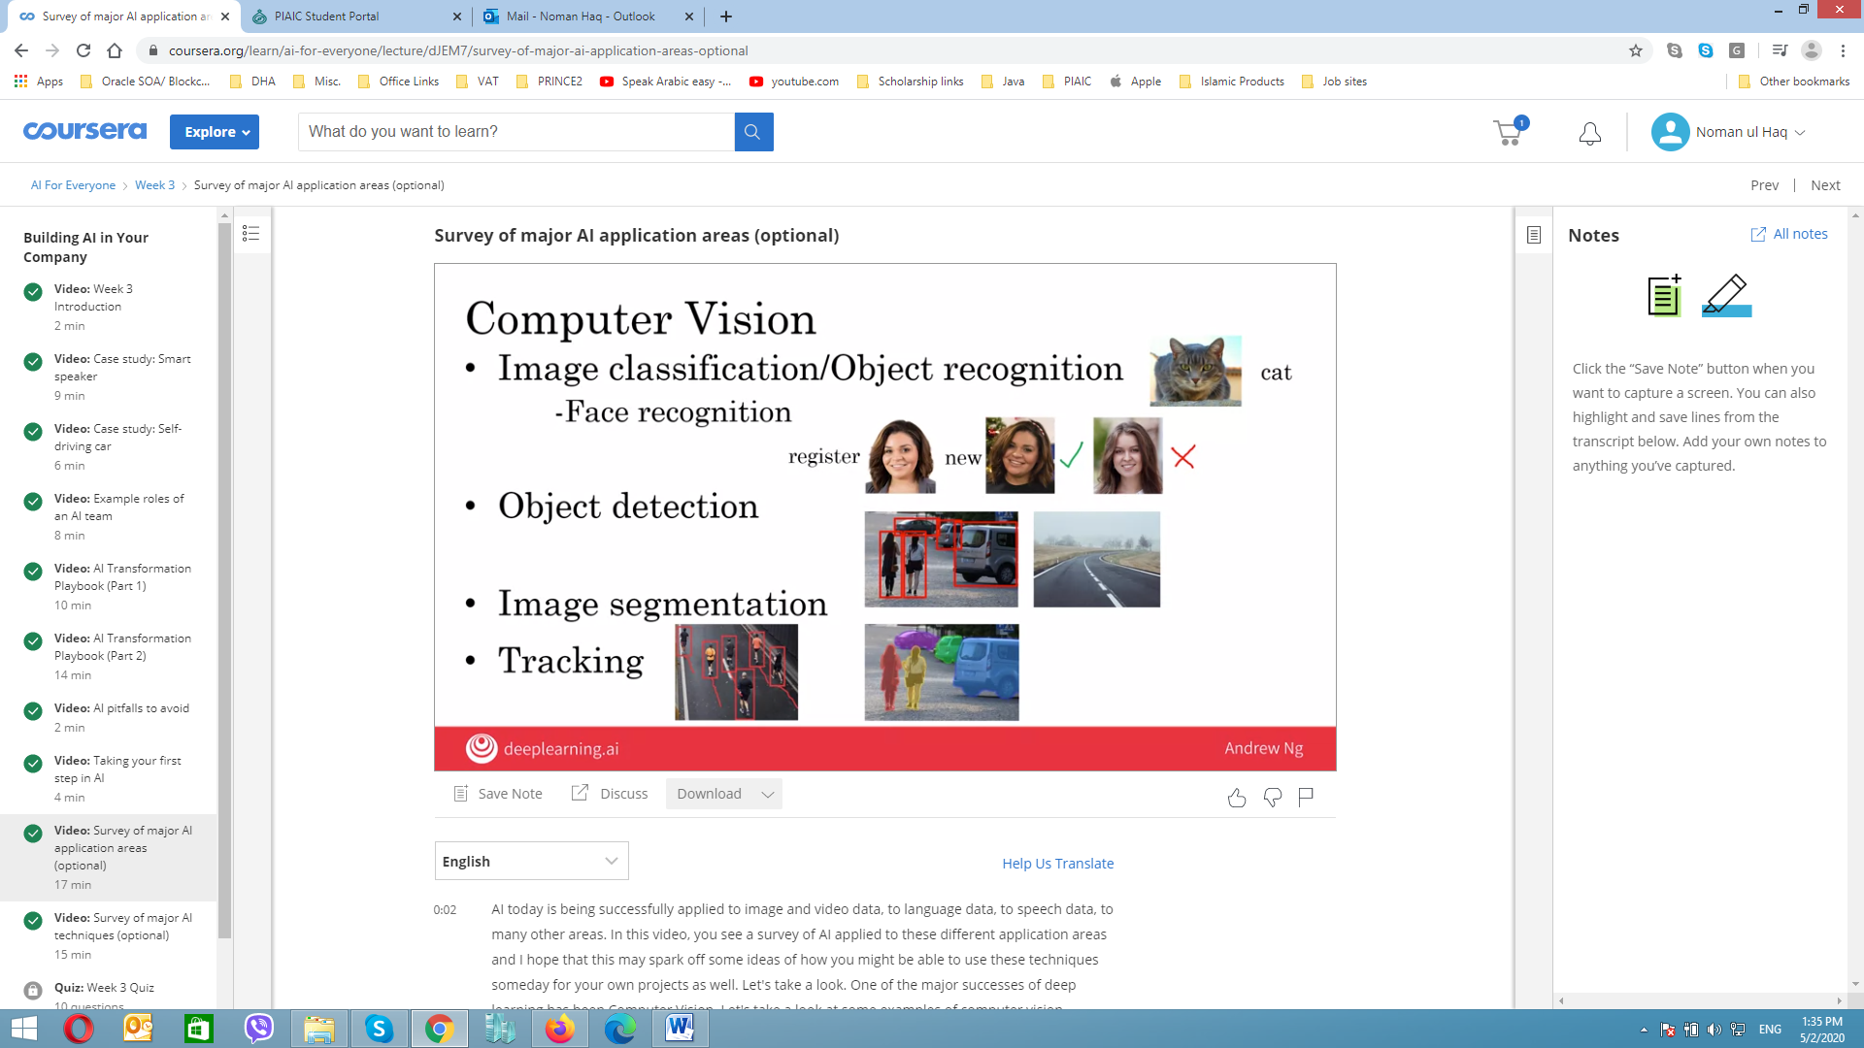

### National Language processing

**Four major categories of useful NLP applications:** Text classification, Information retrieval, Name entity recognition, Machine translation

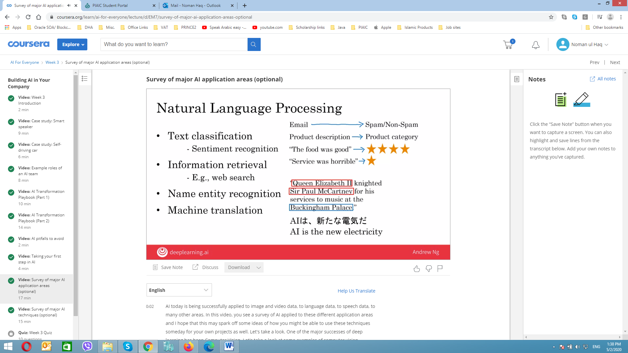

**Others**: Parsing, part of speech testing

**Speech**: Speech recognition (speech to text), Trigger Word/ wake word detection, Speaker ID, Speech synthesis (text to speech, TTS)

**Robotics**:   
**Perception**: figure out what’s in the world around you  
**Motion planning**: finding a path for robot to follow  
**Control**: sending command to the motors to follow a path

**General Machine Learning:**  
**Unstructured data**: Images, audio and text in different language   
**Structured data**: in tabular for with labels

### Unsupervised learning

**Clustering,   
Transfer Learning:** Car detection, Golf cart detection   
**Reinforcement Learning:**

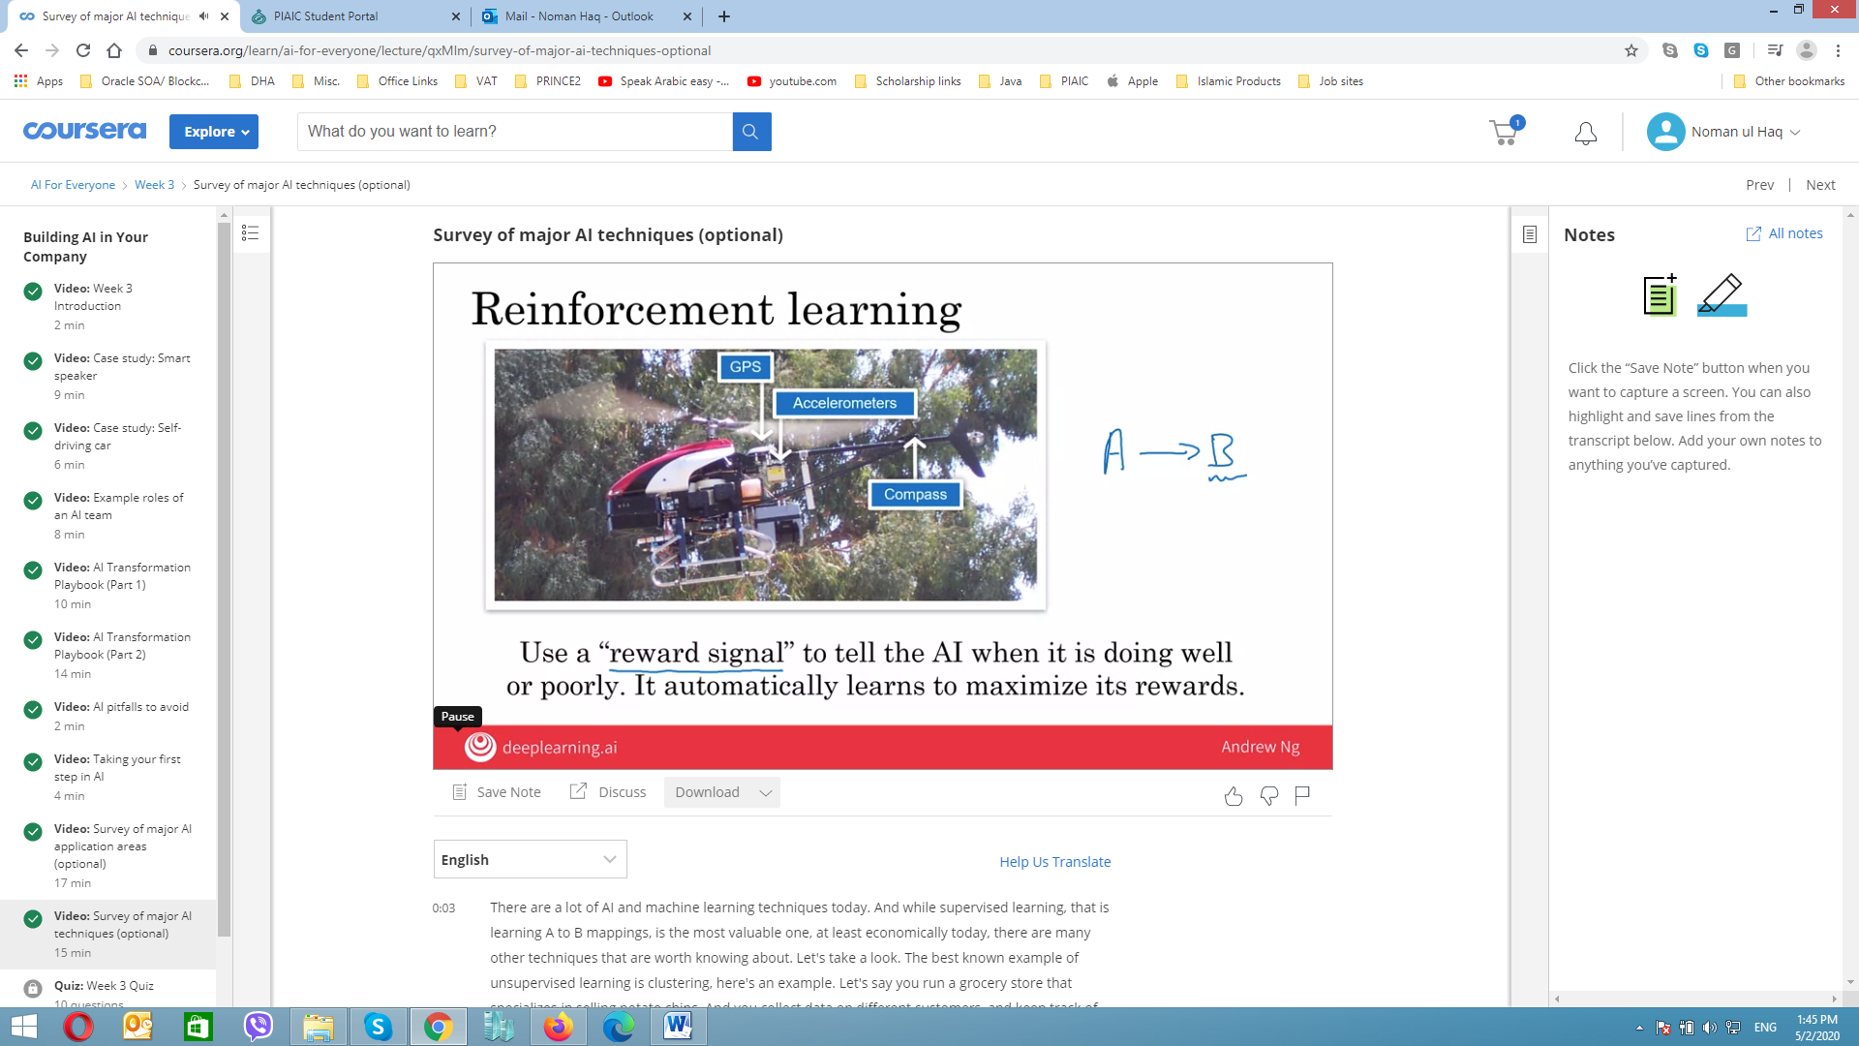 **GANs (Generative Adversarial Network):** synthesizes new image from scratch which is not exists

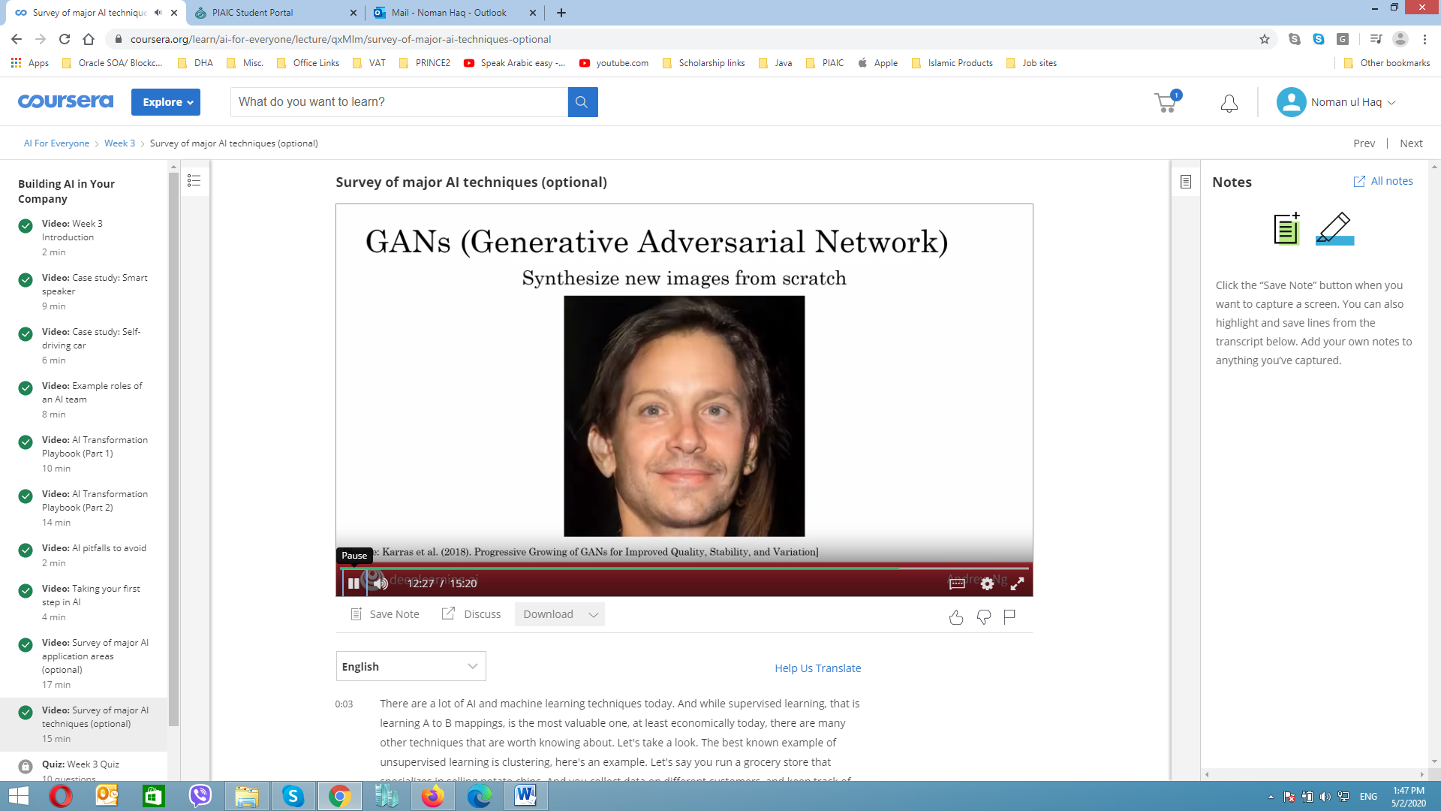 **Knowledge Graph:** mostly use by google, for say if you search any person it automatically gives us information of that person or right side panel which includes person birth, passed away, nationality etc.

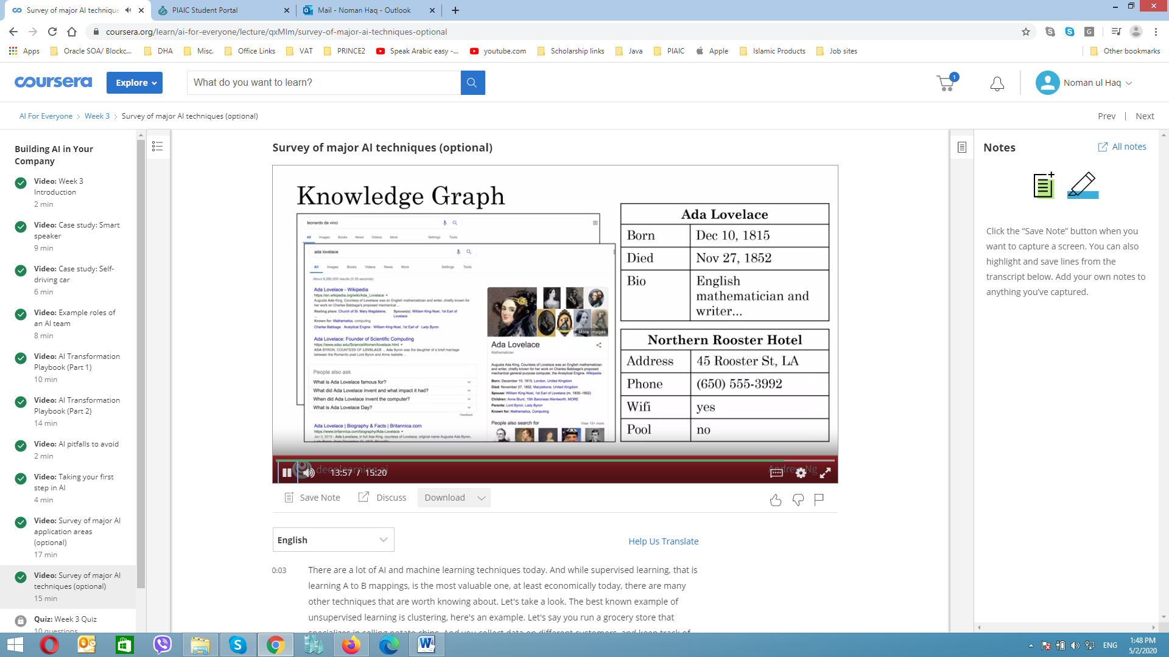

## Week 4

### AI and Society

A realistic view of AI   
Goldilocks rule for AI

* **Too Optimistic**: Sentient/ Super-intelligent AI killer robot coming soon
* **Too pessimistic**: AI cannot do everything, so AI winter is coming
* **Just right**: AI can’t do everything, but will transform industries

## Limitation of AI

* Performance limitations (Limited data availability)
* Explainability is hard (but some time doable) Example – Chest Xray and its diagnosis
* Biased AI Through biased data
* Adversarial attack on AI (modified form of images to model, disturb the model)

### Why bias matter

* Hiring tool that discriminated against women
* Facial recognition working better for light skinned then dark skinned individuals
* Bank loan approvals
* Toxic effect of reinforcement unhealthy stereotype

### Combating bias

* Technical solutions
  + Eg. “zero out” the bias in word
  + Use less biased and/or more inclusive data ( For example, if you are building a face-recognition system, and make sure to include data from multiple ethnicities, and all genders, then your system will be less biased and more inclusive.)
* Transparency and or auditing processes
* Diverse workforce
  + Creates less bias application

### Adversarial attacks on AI System

* Hummingbird >>>> Hammer
* Hare >>>> Desk
* Physical attack
  + Milla Jovovich (with the picture of same glasses by another person)
  + Stop sign (fail to see stop sign)
  + Banana picture (with or without piece of papers )
* Adversarial defense
  + Defenses do exists, but incur some cost
  + Similar to spam vs anti-spam, we may be in an arms of race for some application

### Adverse uses of AI

* DeepFakes
  + Synthesize the video of people doing things they never did
* Undermining of democracy and privacy
  + Oppressive surveillance
* Generating fake comments
* Spam vs anti-spam and fraud vs. anti-fraud

### Developing economies

* LeapFrog
  + Mobile phones, mobile payments, online education,

### How developing economies can build AI

* US and China are leading, but all AI communities are still immature
* Focus on AI strengthen a country vertical industries
* Public private partnership to accelerate development
* Invest in education

### AI Impact on Jobs

* Job displaced by 2030 400-800 million
* Jobs created by 2030 555-890 million
* New jobs may be drone traffic optimizer, 3D printing clothing designer, custom DNA based drug designer, etc.

### Some solution for unemployment

* Conditional basis income: provide a safety net but incentivize learning
* Lifelong Learning (online learning)
* Political solution

### Conclusion

* What is AI?
* Building AI Projects
* Building AI in your company
* AI and Society